Assignment 4

# Question 1

## Section b

We will prove using induction on the number of the operands ($n$):

Base Case:

$n = 1$:

The function $pipe$ will get $a_{1}$ (the operand) and return it, so we will get $cont∘a_{1}$.

The function $pipe\$$ will get $a_{1}$ and $cont$, so $(cdr fs)$ will be empty and $(car fs)$ will be $a_{1}$, therefore the function will return $cont∘a_{1}$. In conclusion, they are equivalent.

Induction Hypothesis: We assume that for $n$ operands the functions are equivilant.

Induction Step:

Assume that we give the functions $n+1$ operands $(a_{1} a_{2} … a_{n+1})$.

$pipe$ will return $cont∘a_{1}∘a_{2}∘⋯∘a_{n+1}$.

$pipe\$$ will start by checking if $(cdr fs)$ is not empty (and indeed it is not), so it will return the value that comes back the call:

$$\left(pipe\$ a_{2} a_{3}⋯a_{n+1} \left(lambda \left(pipe-res\right) \left(cont \left(compose\$ a_{1} pipe-res\right)\right)\right)\right)= \\ \left(pipe\$ a_{2} a_{3}⋯a_{n+1} \left(lambda \left(pipe-res\right) \left(cont∘a_{1} pipe-res\right)\right)\right)\overset{IH}{=} \\ \left(cont∘a_{1}∘ a_{2}∘⋯∘a_{n+1}\right) pipe-res$$

# Question 2

## Section d

We'll use reduce1-lzl when we are only interested in the final result and when we know the list is finite.

We'll use reduce2-lzl when the list may be infinite and/or when we are interested only in some prefix of it (for example when approximating some values up to a certain precision).

We'll use reduce3-lzl in the same scenario of reduce2-lzl, but this time we are also interested in the process (to draw a graph, maybe).

## Section g

Advantages are that when using generate-pi-approximations we only calculate the desired values when we want them - no redundant calculations are made. We also do not use recursion - and thus saving a lot of space (on the call stack for example). Disadvantages may be that pi-sum gives us the ability to decide when to stop calculating depending on the actual fraction and not on the number of steps - thus it is more predictable and flexible.

# Question 3

## Section 1

1.

$$[x\left(y\left(y\right), T, y, z, k\left(K\right), y\right)= x\left(y\left(T\right), T, y, z, k\left(K\right), L\right], \{ \} \\ \left[y\left(y\right)=y\left(T\right), y=L\right], \left\{ \right\} \\ \left[y=T, y=L\right], \left\{ \right\} \\ \left[y=L\right], \left\{y=T\right\} \\ \left[ \right], \{y=T, y=L\}$$

2.

$$\left[f\left(a, M, f, F, Z, f, x\left(M\right)\right)= f\left(a, x\left(Z\right), f, x\left(M\right), x\left(F\right), f, x\left(M\right)\right)\right], \left\{ \right\} \\ \left[M=x\left(Z\right), F=x\left(M\right), Z=x\left(F\right)\right], \left\{ \right\} \\ \left[F=x\left(M\right), Z=x\left(F\right)\right], \left\{M=x\left(Z\right)\right\} \\ \left[Z=x\left(F\right)\right], \left\{M=x\left(Z\right), F=x\left(M\right)\right\} \\ \left[ \right], \left\{M=x\left(x\left(F\right)\right), F=x\left(x\left(x\left(F\right)\right)\right), Z=x\left(F\right)\right\}-f appears in both sided of the equation-failure.$$

3.

$$\left[t\left(A, B, C, n\left(A, B, C\right),x, y\right)= t\left(a, b, c, m\left(A, B, C\right), X, Y\right)\right], \left\{ \right\} \\ \left[A=a, B=b, C=c, n\left(A, B, C\right)=m\left(A, B, C\right), x=X, y=Y\right], \left\{ \right\} \\ \left[n\left(A, B, C\right)=m\left(A, B, C\right), x=X, y=Y\right], \left\{A=a, B=b, C=c\right\}-m and n are not the same predicate-failure.$$

4.

$$\left[z\left(a\left(A, x, Y\right), D, g\right)= z\left(a\left(d, x, g\right), g, Y\right)\right], \left\{ \right\} \\ \left[a\left(A, x, Y\right)=a\left(d, x, g\right), D=g, g=Y\right], \left\{ \right\} \\ \left[A=d, Y=g, D=g\right], \left\{ \right\} \\ [ ], \{A=d, Y=g, D=g\}$$

## Section 3

edge(a,b). %e1

edge(a,c). %e2

edge(c,b). %e3

edge(c,a). %e4

path(Node1, Node2, Path)

:- edge(Node1, Node2), Path = [Node1, Node2]. %p1

path(Node1, Node2, Path)

:- edge(Node1, Node3), path(Node3, Node2, Path1),

Path = [Node1 | Path1].  %p2

path(a, b, P)

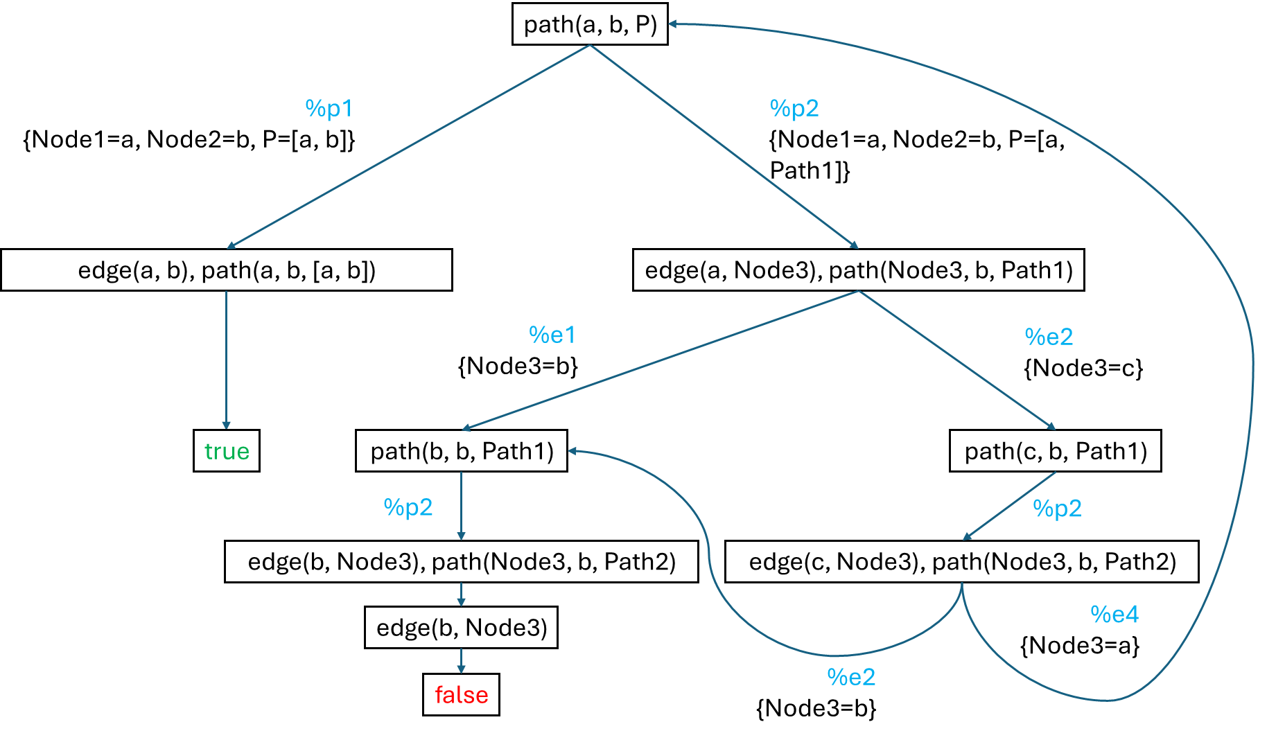

It is an infinite tree and also a success tree.